Unit 3 – Cognition 3.5 Concepts & Processes of Memory
- 3.5 psychological concepts & processes associated with memory and their relationship to behaviour
- multi store model of memory – Atkinson and Shiffrin, 1968
- sensory register
  - duration, capacity, encoding
- short-term memory (working memory)
  - duration, capacity and encoding
- long-term memory
  - duration, capacity and encoding
  - procedural memory
  - declarative memory – semantic and episodic
- recall, recognition, re-learning
- forgetting: retrieval failure, interference, motivated forgetting, decay
  - working memory model – Baddeley and Hitch, 1974

Memory can be regarded as information processing; it involves paying attention, converting information to a form for storage in the brain, and then retrieval of that information when required.
1. Why is memory is so important?
________________________________________________________________________________________________________________________________________________________________________________________________________________________________

Encoding, Storage and Retrieval
2. The information processing model has been compared to a computer. List the comparisons that have been made, using the table below
Process | Encoding | Storage | Retrieval
Definition
Analogy to information processing by a computer

3. Fill in this Memory Model. Which model of memory is this? (clue p 178 SOS) _________________
Memory Model
Incoming information
Sensory memory
Not attended to
Attention
Long-term memory
Forgotten
Short-term (working) memory
Forgotten if not encoded
Rehearsal
Retrieval

Iconic Memory
Features
1. Capacity

2. Chunking

Effects of rehearsal
1. Maintenance

2. Elaboration

Consolidation theory

By rehearsing or recalling information over and over again, neural networks become strengthened. Neurons that fire together wire together so the more you rehearse information (consolidate it) the more accurate and with greater ease you can recall it.

Echoic Memory
Types of long-term memories
1. Procedural

2. Declarative

a. Episodic

b. Semantic

4. Read the information on the Working Memory model.
a. Who developed this model? When? ___________________________________________
b. What is the role of the working memory? Draw an illustration to help you remember.

Using the space below draw an illustration of the Working Memory Model by Baddeley and Hitch (1974).

The central executive is responsible for giving attention to information from the other two stores and making decisions about which information is the most important. Rehearsal occurs between the central executive and the other stores.
The phonological loop is known as the “inner voice” and holds information in a speech based form; it has a limited capacity.
The visuo-spatial scratchpad is known as the “inner eye” and is specialised for spatial and visual coding.
c. Where does this model fit within Atkinson and Shiffrin’s model?
__________________________________________________________________________________
4d. Which cognitive processes is this model showing?
__________________________________________________________________________________
4e. What behaviour may be influenced by these processed?
__________________________________________________________________________________
__________________________________________________________________________________
4f. Name 3 cognitive processes below.
__________________________________________________________________________________
4g. How might a problem with these cognitive processes be seen or recognised in behaviour?
__________________________________________________________________________________

5. Sensory memory (register).
a. Outline the role of the sensory register in memory.
__________________________________________________________________________________
__________________________________________________________________________________

b. What is the duration, capacity and encoding ability of each of the parts of the sensory register?
__________________________________________________________________________________
__________________________________________________________________________________
__________________________________________________________________________________

6. Long term memory (Tulving, 1972- different types of memory)
a. Name and outline the different roles within the long-term memory store.
__________________________________________________________________________________
__________________________________________________________________________________
__________________________________________________________________________________
__________________________________________________________________________________
__________________________________________________________________________________
__________________________________________________________________________________

b. What is the duration, capacity and encoding ability of long term memory?
__________________________________________________________________________________
__________________________________________________________________________________
__________________________________________________________________________________

7. Construct a paragraph summarising how information is encoded, stored and retrieved using sensory, short and long-term memory. Use the models of memory to help you.
________________________________________________________________________________________________________________________________________________________________________________________________________________________________________________________________________________________________________________________________________________________________________________________________________________________________________________________________________________________________________________________________________________________________________________________________________________________________________________________________________________________________________________________________________________________________________________________________________________________________________________________________________________________________________________________________________________________________________________________________________________________________________________________________________________________________________________________________________________________________________________________________________________________________________________________________________________________________________________________________________________________________________________________________________________________________________________________________________________________________________________________________________________

8. Remembering: recall recognition and re-learning.
i. People want to improve memory for many reasons. List a few reasons why you would like a better memory. ____________________________________________________________

ii. What is the difference between the following terms:
Recall: ___________________________________________________________________________
Recognition_________________________________________________________________
Re-learning _________________________________________________________________
iii. Which is easier, recall or recognition? Why?
___________________________________________________________________________
iv. What can the speed of re-learning tell a psychologist about previous learning? ___________________________________________________________________________

Ways to enhance memory: how to improve recall.
a. Organisation: the process of grouping individual items together on the basis of some shared characteristic, association or relationship. Try this activity below:
Describe how organisation helped you recall words.
___________________________________________________________________________
___________________________________________________________________________
b. Context-dependent cues: environmental conditions present at retrieval that match those present at learning. Eg. Participants who learnt words while under water recalled more words when tested in the same state (under water) than those who learned while under water and were tested in a classroom.
Eg. ________________________________________________________________________
___________________________________________________________________________

c. State-dependent cues: cues present at retrieval that are related to learner’s state at the time of learning. Describe evidence relating to emotional state and drug/alcohol use.
________________________________________________________________________

d. Mnemonic devices: any internal strategy that makes it easier to encode, store or retrieve information. They may be visual or verbal and generally impose organisation on the material to be remembered.
True or False: Writing a shopping list on paper is a mnemonic device. ________________
9. Forgetting Reference

There are several reasons why people have problems remembering. In groups, make notes on the following theories of forgetting to share with the class. (Forgetting handout)
a. Retrieval Failure Theory
____________________________________________________________________________________________________________________________________________________________________________________________________________________________________________________________________________________________________________
___________________________________________________________________________

b. Interference Theory
___________________________________________________________________________________________________________________________________________________________________________________________________________________________________________________________________________________________________________________________________________________________________________________
___________________________________________________________________________________________________________________________

c. Motivated Forgetting
____________________________________________________________________________________________________________________________________________________________________________________________________________________________________________________________________________________________________________________________________________________________________________________
d. Decay Theory
____________________________________________________________________________________________________________________________________________________________________________________________________________________________________________________________________________________________________________________________________________________________________________________
Revision

Make yourself familiar with the Multi-Store Memory Model by Atkinson and Shiffrin (1968) below, and the Working Memory model by Baddeley and Hitch (1974).
Review the Multi-Store Memory Model by Atkinson and Shiffrin (1968), shown below.
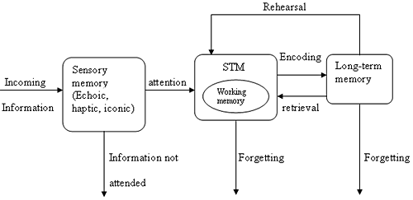

Make notes on this information processing model under the headings sensory memory, short-term memory and long-term memory.

__________________________________________________________________________________
__________________________________________________________________________________
__________________________________________________________________________________
__________________________________________________________________________________
__________________________________________________________________________________
__________________________________________________________________________________
__________________________________________________________________________________
__________________________________________________________________________________
__________________________________________________________________________________
__________________________________________________________________________________
__________________________________________________________________________________
__________________________________________________________________________________
__________________________________________________________________________________
__________________________________________________________________________________
__________________________________________________________________________________
__________________________________________________________________________________
__________________________________________________________________________________
__________________________________________________________________________________
__________________________________________________________________________________
Below is a detailed illustration of the Working Memory Model by Baddeley and Hitch (1974).p 179 SOS
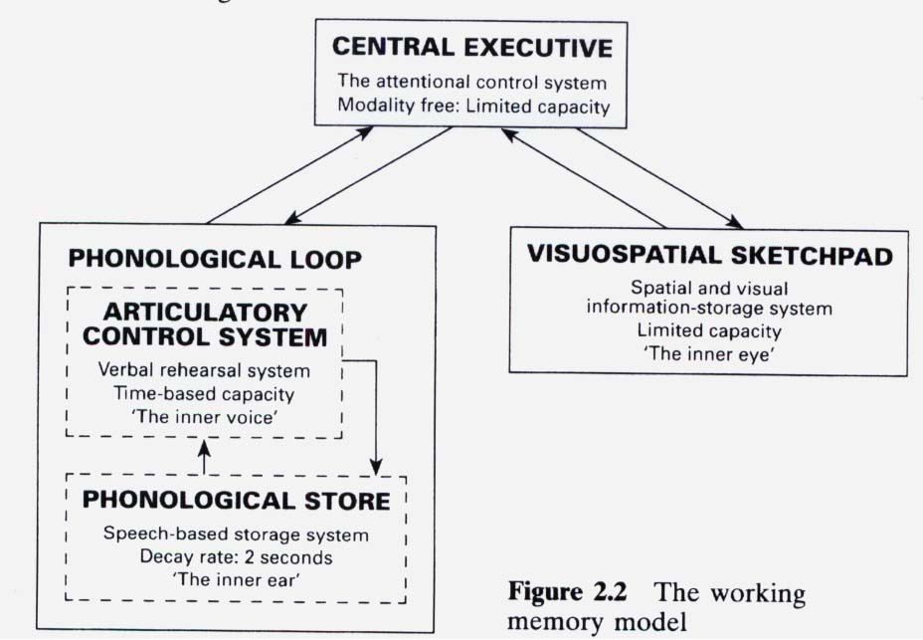

Learn and review.
__________________________________________________________________________________
__________________________________________________________________________________
__________________________________________________________________________________
__________________________________________________________________________________
__________________________________________________________________________________
__________________________________________________________________________________
________________________________________________________________________________

Pay attention, gain information Encode, convert information Storage, keep Retrieval, get it back
Rehearsal
Attention
Sensory Information Short Term Memory Long Term Memory
Retrieval
Forgotten
Forgotten
Visual/sight*
Auditory/sound**
Kinaesthetic/movement
Smell

Networks/Connections
Semantic network theory
Capacity
Chunking
Not remembered
1. Procedural – the ‘how to’ of memory
e.g. how to open a door
2. Declarative – the ‘what’ of memory
e.g. history dates, events
2a. Episodic – the ‘episodes’ of memory
e.g. a family picnic
2b. Semantic – the thing you remember in
words e.g. facts
* The visuo-spatial scratchpad (sketchpad) stores/manipulates visual and spatial information and will be active when the person is doing a visual task.

** The phonological loop, comprising the phonological store (inner ear) and articulatory control system (inner voice) will be active during a verbal task.

(Ebbinghaus- Studies on recall of nonsense syllables)
Enhance Memory
- Context- dependant cues (same environment)
- State-dependant cues (same emotion)
- Mnemonic devices ( -narrative chain, acrostics, acronyms, memory palaces etc)
Recognition is easier than recall because it gives a cue; matching.
Sensory memory: large capacity, very short time span (several seconds)
STM (short term memory) limited capacity: 7 + or – 2 lasts 30s with maintenance. Often verbal acoustic.
LTM(long term memory) unlimited capacity, unlimited time elaborative, associative encoding.

- Retrieval failure theory: Need to cue to remember without cue, may not retrieve memory.
- Interference theory: Need uninterrupted time for STM LTM
- Freud suggests: “Motivated forgetting”: unconscious, unintentional, but preserve someones’ sanity.
- Suppression: People consciously try to forget unwelcomed memori

